
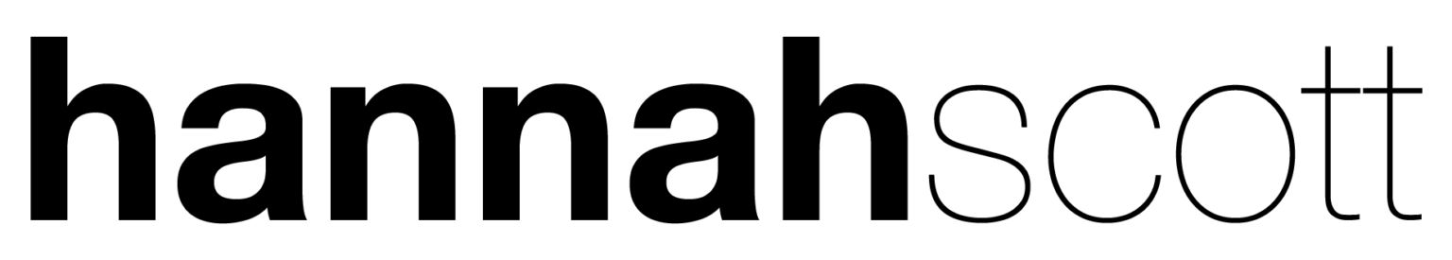

Live Biography

The best stories make us feel deeply and in the 15 years she has been writing and performing, Hannah has become an exceptional storyteller. Her music is shaped by human connections, with family, in all its chaos and glory, sitting at the heart of her work. Her lyrics are powerful and poignant, and her voice feels strangely familiar, though you can’t quite put your finger on why. Her writing may be deeply personal but her music has a universal appeal that goes beyond the melodies you catch yourself humming in the days after listening to her songs.

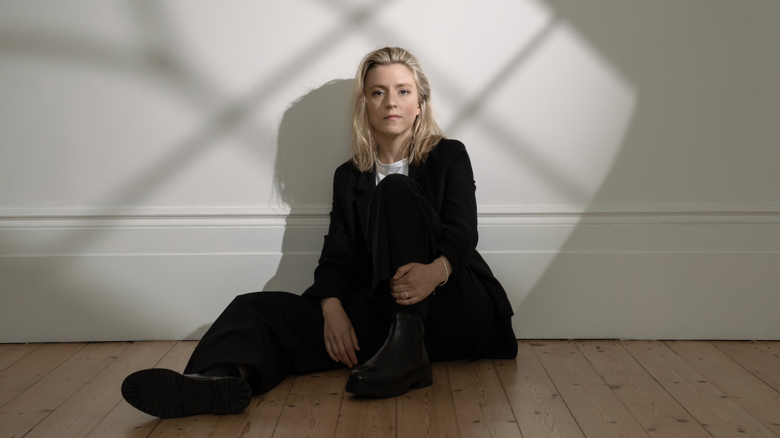
Career highlights include having her song No Gravity featured on the hit international TV series Grey’s Anatomy, recording a live session on BBC Radio 2 with Dermot O’Leary and opening for Madeleine Peyroux, performing to an audience of two thousand. She has also shared the stage with folk luminaries such as Seth Lakeman, Cara Dillon and Fairport Convention and has performed at festivals including Cambridge, Sidmouth and Manchester Folk. Equally at home in small venues, she thrives on the intimacy of performing in spaces where she can look audience members in the eye.

Hannah is currently touring to support the release of her EP Threads, a follow-up to the widely praised 2024 album Absence Of Doubt. It marks the first release she has both written and produced, working alongside acclaimed engineer Adrian Hall (Tori Amos, Anna Calvi).

Quotes

“She reduces women and children to tears - in a good way…”
The Guardian

“…and grown men.”
Tom Besford, English Folk Expo & Richard Haswell, Liverpool Philharmonic

“This is beautiful.”
Dermot O’Leary, BBC Radio 2

“Wonderful songwriting.”
Seth Lakeman

“She screams class but in the quietest way possible.”
Folking.com

Links

hannahscott.co.uk
facebook.com/hannahscottuk
twitter.com/hannahscottuk
instagram.com/hannahscottuk
youtube.com/hannahscottuk

For more information, please contact Ant Miles at Fancourt Music
ant.miles@fancourtmusic.com | +44 7837 881941 | fancourtmusic.com

